NSDC

LOCAL INNOVATIONS SCALED THROUGH ENTERPRISE NETWORKS-LISTEN MODEL IN KIAMBU

KIAMBU COUNTY SUB COUNTY LISTEN COORDINATORS CHARTER

Background

NACC was established in September 1999 as a State Corporation through a Legal Notice No. 170 of 1999. The NSDC was later in 2022 renamed the National Syndermic Control Council-NSDC with an expanded mandate.

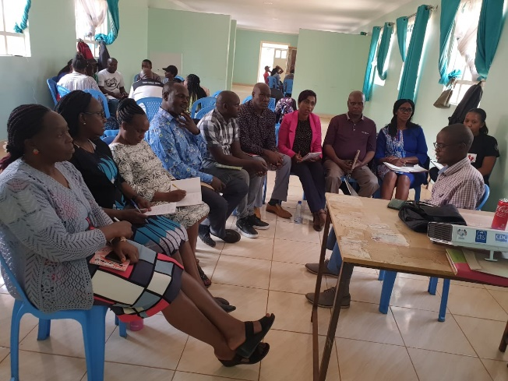However, part of the mandate still remains to coordinate the national and multi-sectoral HIV and AIDS response to reach goals articulated in the Constitution of Kenya, the Bill of Rights including the right to the highest attainable standard of health care, national values to which all public officers ascribe and importance of citizen participation especially in the HIV and the health sector. NSDC recognizes the diverse institutional mandates that facilitate the HIV response and governance systems that enhance performance and accountability for resources and results.

In order to effectively coordinate and deliver on its mandate of multisectoral coordination of community-based HIV response NSDC has devolved functions to the Sub County level.

Goals and objectives

Coordination of community-based HIV and AIDS related activities.

Objectives

To initiate and oversee community HIV interventions e.g Community HIV and AIDS dialogue/action days.

To Provide technical support for HIV and AIDS implementers (community, public, private, faith based) in the respective Sub-county.

To advocate for existing strategies and activities that address specific needs of vulnerable groups, PLHIV and key populations.

Take lead in organising and participation in HIV and AIDS advocacy forums such as World AIDS Day.

To initiate resource mobilization strategies to respond to HIV and AIDS at the sub-county level.

Kiambu County LISTEN Coordinators areas of interest

Coordination of community-based HIV & Health programs

Advocacy

Active participation in Technical working groups

Anti-stigma and discrimination campaigns

Liaison between the national and county government for synergy in HIV and AIDS response.

Support supervision and technical support to community-based HIV responders including CPs

Mobilization of communities for HIV response

Mobilize of resources for HIV response

Dissemination of relevant policies, guidelines and information

Monitoring and evaluation

Monthly reports

Activity reports

Community based data management/quality assurance

World AIDS day reports

Health days reports

|  |  |  |  |
| --- | --- | --- | --- |
| What matters to the Kiambu County LISTEN Coordinators | Priorities | Recommendations | Responsible office/institution |
| Advocacy forums | Dissemination of HIV and AIDS information.  Dissemination of information on STIs | Leverage on health and non-health fora for advocacy  Support UHC at the community level  Support for Mental health | Kiambu County LISTEN Coordinators  RHC  County government  NSDC |
| Teenage pregnancies | Reduction of teenage pregnancies  Attendance of ANC clinics by teenage mothers | Identification of pregnant teenage girls  Collaborations with stakeholders to keep girls in school, working with school health program for anti-teenage pregnancy campaigns | LISTEN  NSDC  Kiambu County LISTEN Coordinators  National and County government  Childrens Department  Safe spaces and shelters |
| SGBV | Reduction of SGBV  Response to SGBV | Information sharing  Collaborations for response to SGBV | Kiambu County LISTEN Coordinators  Department of Health  National Government  Safe spaces and shelters |
| HIV and AIDS prevention | Prevention of new HIV infections  Identification of PLWHIV  Community response to PMTCT  Male engagement for HIV response  Distribution of condoms  Mapping of hotspots for condom distribution and installation of condom dispensers  Distribution of lubricants  Reduction of SGBV cases  Reduction of STIs  Community response to drugs and substance abuse | Inter CP collaborations  Targeted outreaches  Information sharing-HIV and AIDS, STIs, alcohol and drugs abuse and emerging epidemics  Demonstration and distribution of condoms  Demonstration and distribution of HIV self-test kits  Installation of condom dispensers  Identification of hotspots  Distribution of lubricants  Information sharing on KPs and Human Rights  Anti-stigma campaigns  Information sharing on HIV prevention options-PEP, PrEP etc  Linkage and referrals for health services | National government  NSDC  Kiambu County LISTEN Coordinators |
| Multisectoral engagements | Creation of effective networks for HIV, teenage pregnancies and SGBV response | Leverage on all available fora to address HIV and AIDS, teenage pregnancies and SGBV | County LISTEN Coordinators  NSDC |

KIAMBU COUNTY LISTEN COORDINATORS COORDINATION STRUCTURE

Kiambu county LISTEN coordinators is a group of Technical HIV experts tasked with community HIV response at the Sub County level. The coordinators are a devolved structure of the NSDC at the community level. They coordinate and support community HIV response, monitoring and evaluation.

The CP coordinates, offers technical support, supervises and supports horizontal and vertical linkages for LISTEN.

The CP oversights, participates in activities and supports the community level CPs-Bodaboda, Male Champions, YACH and Maisha Youth.

The CP members work under the County LISTEN TWG and report to the RHC; at the county level the CP members are professionally under the Directorate of Public Health and sanitation.

|  |
| --- |
| **RHC**  **MAISHA YOUTH CP**  **COUNTY DIRECTOR PUBLIC HEALTH**  **TWG CP**  **MALE CHAMPIONS CP**  **BODABODA CP**  **KIAMBU COUNTY COORDINATORS LISTEN CP**  **YACH CP** |

SWOT ANALYSIS

**OPPORTUNITIES**

LISTEN

HCD

*Restructuring of the NSDC

Community confidence

Potential collaboration and partnerships

Strong relations with the department of Health

Inter CP collaborations

Application of HCD

**STRENGTHS**

* Vast technical knowledge and expertise in Health
* Positive influence at the community
* Great advocacy, mobilization, networking, skills
* Ability to coordinate multisectoral interventions

**WEAKNESSES**

* Lack of formal requirements for reporting by community actors
* Siloing of programs









**THREATS**

*Restructuring of the NSDC

Deficiency in logistical support

Poverty.