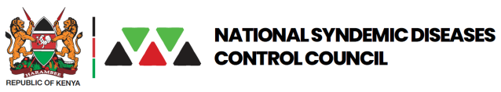 

**Mfangano Adolescents, Youth and young persons (AYP) CHARTER 2022**

**1.0 Background:**

The AYP Charter was drafted to increase youth involvement in matters concerning them,

The first batch of champions. The youth champions are drawn from the different islands in Mfangano; (Sena, Takawiri,Yokia,Remba)

**2.0 Goal and Objectives (What, why, When)**

**Goal:** Speer heading health issues among the youths including: HIV, GBV, SRH mental wellness among adolescents & young persons aged (15-24 years) in Homabay County

**Objectives: (How) –**

1. Creating awareness through Sensitization forums – outreaches, tournaments, community campaigns

2. Provision of Information on Sexual Reproductive Health

3. Provision of life skills

4. Entrepreneur skills, self-employment and IGAs for the AYPs

**3.0 Challenges Experienced by the AYP**

Teenage pregnancy

Drug and substance abuse

Education and School drop out

Early marriages

Climate change

Mental health issues-Dipression

Diseases like STI’s and HIV

SGBV

Social factors; (peer pressure, poverty, social media influence

Early boy-girl relationship without guidance and protection

Lack of parental education

Limited peer educators

Lack of jobs

Poor mindset

Lack of youth programs and youthful peer educators

**4.0 Health and HIV Areas of Interest**

1. HIV prevention, care and treatment
2. Sexual and reproductive health information
3. teenage pregnancies
4. Health Insurance - NHIF
5. GBV/SGBV

6. Mental Health - Depression

**5.0 Approach in Programming/ Implementation**

1. Community and facility outreaches,

2. Sensitizations and awareness creation through ongoing community activities

3. Partnerships with the county and implementing partners in the community to aid in relevant IEC materials.

4. Conduct a capacity building training to members on HIV, GBV, SRH and mental

health

5. Online campaigns that will help in demand creation;, twiter, face book, Youtube

6. Use of real-life stories for SGBV Survivors, PLHIV and PMTCT to support those in denial and experiencing stigma and discrimination to cope

**5.0 Priority Areas**

1. Teenage pregnancies
2. HIV prevention
3. Mental health
4. Sexual & Reproductive Health
5. Social Security

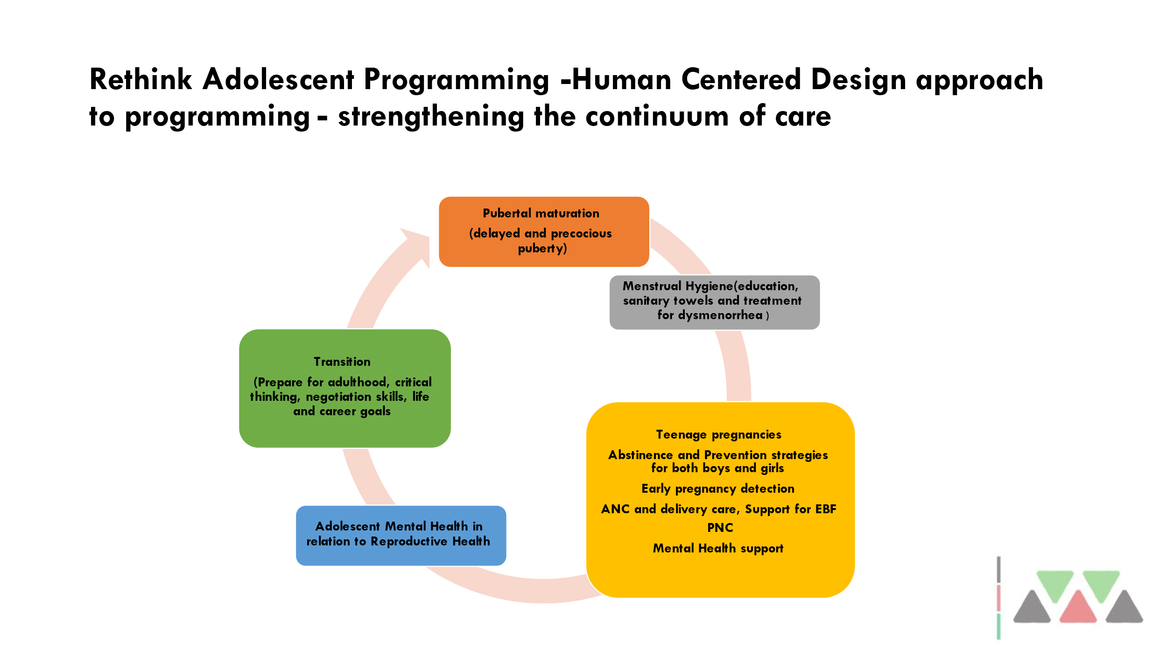

|  |  |
| --- | --- |
| PRIORITY AREAS | ACTIVITIES |
| HIV Prevention | 1. Organizing sporting activities  • Football tournaments: branding of fliers and T-shirts with  HIV prevention messages, Voluntary HIV testing services,  family planning counseling and distribution of condoms,  • Organizing cycling racing  • Team building activities  • Marathon  2. Medical open days  3. Social media campaigns  • Twitter chats & space  • Facebook platform  Short video clips  • Community radio platforms  4. Color festival  5. Talent show |
| Sexual Reproductive Health (SRH) | Distribution of menstrual care packages to female students &  young females in the community.  • SRH awareness campaigns through school health programs  & media platforms  • Disseminating age appropriate information materials, such as  pocket size booklets in schools |
| Mental Health | Mental health awareness campaigns,  • Drug & substance abuse awareness,  • Organizing fun day, art therapy  • Organizing rallies  • Talent shows,  • Training peer educators in schools  • Formulating clubs addressing mental health and people living  with HIV  • Community service e.g., street clean ups |
| Social security Issue | Organizing workshops in collaboration with relevant  organizations to sensitize the youth on entrepreneurial skills,  importance of NSSF accounts, importance of NHIF  accounts.  • Conduct training on life skills and self-advocacy |

**6.0 Monitoring & evaluation**

* Monthly Reporting through the ODK
* Update through wats-up forum
* Reports and other supporting documentations
* Pictorial evidence
* Review of progress and Feedback meetings
* Attendance list
* Training reports

**7.0 Coordination Framework**

Leaders elected by members consisting of(Chairman Secretary and treasurer)

The different AYP CPs are attached to a local facility and give feedback to the subcounty and county adolescent focal person.

**ANNEX 1: SWOT ANALYSIS OF THE YACH CP**

|  |  |  |
| --- | --- | --- |
|  | Positive | Negative |
| **Internal**  **Factors** | **Strengths (Things currently**  **going well)**  Majority of the stakeholders are youths  Most youths have access to social media  platforms and other sources of  information  Previous experiences when dealing with  youths  Strong support system from the county  and National Syndemic Diseases Control | **Weaknesses (Things that**  **aren’t currently going well)**  Inadequate expertise on matters affecting  youths  Limited scope of focus on capacity  building  Coordination challenge due to  geographical distance  Uneven representation of all sub-counties |
| External factors | **Opportunities (These exist**  **now and in the future worth pursuing**  **to achieve the expected result)** Youths  form the largest population in Kenya Most youths are faced with challenges in  the priority areas  Policies in place support the  implementation of youth programs  Existing of organizations that support and  fund youth friendly activities.  More AYPs willing to join the team  More organizations willing to collaborate | **Threats (Possible obstacles**  **that exist now)**  Poor public perception of HIV, SRH & Mental health Misinformation from the internet and other sources of information Poor resource management  Covid-19 pandemic  Limited time to achieve all the activities |